|  |  |  |
| --- | --- | --- |
|  | |  |
|  | Lab report 06  **Build, Test and Use Straight-Through and Cross-Over UTP Cable**  **_____________________**  **304L-Data Communcation and Computer Networks Lab**  **Department of Computer System Engineering**  **University of Engineering and Technology Peshawar**  Submitted to: **Dr. Yasir Saleem Afridi**  Submitted by: **Muhammad Saad**  Reg ID: **21PWCSE1997**  **DCSE, Batch 23, Section “B”**  Date: **Tue, May** **21, 2024** |
| |  |  |  |  |  | | --- | --- | --- | --- | --- | | **Demonstration** **of** **Concepts** | **Poor** **(Does** **not** **meet** **expectation** **(1))**  The student failed to demonstrate a clear understanding of the assignment concepts | **Fair** **(Meet** **Expectation** **(2-3))**  The student demonstrated a clear understanding of some of the assignment concepts | **Good** **(Exceeds** **Expectation** **(4-5)**  The student demonstrated a clear understanding of the assignment concepts |  | | **Score**  **30%** | | **Accuracy** | The student mis-configured enough network settings that the lab computer couldn't function properly on the network | The student configured enough network settings that the lab computer partially functioned on the network | The student configured the network settings that the lab computer fully functioned on the network |  | | **30%** | | **Following** **Directions** | The student clearly failed to follow the verbal and written instructions to successfully complete the lab | The student failed to follow the some of the verbal and written instructions to successfully complete all requirements of the lab | The student followed the verbal and written instructions to successfully complete requirements of the lab |  | | **20%** | | **Time** **Utilization** | The student failed to complete even part of the lab in the allotted amount of time | The student failed to complete the entire lab in the allotted amount of time | The student completed the lab in its entirety in the al |  | | **20%** |   **CSE** **303L:** **Data** **Communication** **and** **Computer** **Networks**  **Credit** **Hours:** **1**  CSE 303L: Data Communication and Computer Networks  Credit Hours: 1 | |

|  |  |  |
| --- | --- | --- |
|  | |  |
|  | **Lab report: 06**  **Build, Test and Use Straight-Through and Cross-Over UTP Cable**  **OBJECTIVES:**  **----------------------------------------------------------------------------------------------------**  • In this lab, we will cover the following: • Introduction to Transmission Media  • Build a Category 6 (CAT 6) Straight-Through Ethernet network cable • Build a Category 6 (CAT 6) Cross-Over Ethernet network cable  • Test both cables for good connection using Cable Tester  • Connecting Computers via Switch using Straight Through Cable and Connecting two computers directly via Cross Over Cable  **----------------------------------------------------------------------------------------------------**  **TRANSMISSION MEDIA**  The transmission media is nothing but the physical media over which communication takes place in computer networks. The transmission of data over transmission media may be unguided (wireless) or guided (wired).  **WIRELESS**  Wireless transmission is a form of unguided media. Wireless communication involves no physical link established between two or more devices, communicating wirelessly. Wireless signals are spread over in the air and are received and interpreted by appropriate antennas.  When an antenna is attached to electrical circuit of a computer or wireless device, it converts the digital data into wireless signals and spread all over within its frequency range. The receptor on the other end receives these signals and converts them back to digital data.  **WIRED**  In wired communication a physical link is established between two devices. The link may be of different types.  **WAVE GUIDE** |
|  | |

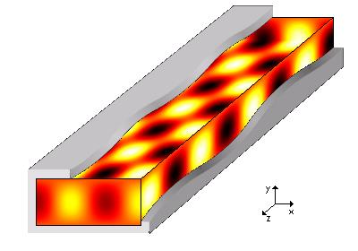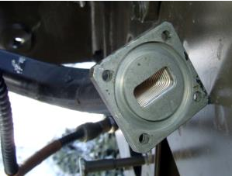

|  |  |  |
| --- | --- | --- |
|  | |  |
|  | A waveguide is a structure that guides waves, such as [electromagnetic waves](http://en.wikipedia.org/wiki/Electromagnetic_wave) or [sound](http://en.wikipedia.org/wiki/Sound) waves. There are different types of waveguides for each type of wave. The original and most common meaning is a hollow conductive metal pipe used to carry high frequency [radio waves,](http://en.wikipedia.org/wiki/Radio_wave) particularly [microwaves.](http://en.wikipedia.org/wiki/Microwave)  The geometry of a waveguide reflects its function. Slab waveguides confine energy to travel only in one dimension, fiber or channel waveguides for two dimensions. The frequency of the transmitted wave also dictates the shape of a waveguide: an [optical fiber](http://en.wikipedia.org/wiki/Optical_fiber) guiding high-[frequency](http://en.wikipedia.org/wiki/Frequency) [li](http://en.wikipedia.org/wiki/Light)ght will not guide [microwaves](http://en.wikipedia.org/wiki/Microwaves) of a much lower frequency. As a [rule of thumb,](http://en.wikipedia.org/wiki/Rule_of_thumb) the width of a waveguide needs to be of the same [order of magnitude](http://en.wikipedia.org/wiki/Order_of_magnitude) as the [wavelength](http://en.wikipedia.org/wiki/Wavelength) of the guided wave.  Some naturally occurring structures can also act as waveguides. The [SOFAR channel](http://en.wikipedia.org/wiki/SOFAR_channel) layer in the ocean can guide the sound of [whale song](http://en.wikipedia.org/wiki/Whale_sound) across enormous distances.  **(b)**  **Figure** **3.1.** **(a)** **A** **section** **of** **flexible** **waveguide** **with** **a** [**pressurizable** **flange.**](http://en.wikipedia.org/wiki/Waveguide_flange) **(b)** **Electric** **field** **inside** **an** **x-band** **hollow** **metal** **waveguide.**  **CABLE**  Alternatively referred to as a cord, connector or plug, a cable is one or more [wires](http://www.computerhope.com/jargon/w/wire.htm) covered in a plastic covering that [connects](http://www.computerhope.com/jargon/c/connect.htm) a [computer](http://www.computerhope.com/jargon/c/computer.htm) to a power source or other device.Networking cables are used to connect one network device to other network devices or to connect two or more computers to share [printer,](http://en.wikipedia.org/wiki/Printer_(computing)) [s](http://en.wikipedia.org/wiki/Image_scanner)canner etc. Different types of network cables like [Coaxial cable,](http://en.wikipedia.org/wiki/Coaxial_cable) [Optical fiber cable,](http://en.wikipedia.org/wiki/Optical_fiber_cable) [T](http://en.wikipedia.org/wiki/Twisted_Pair)wisted Pair cables are used depending on the network's [topology,](http://en.wikipedia.org/wiki/Network_topology) [p](http://en.wikipedia.org/wiki/Network_Protocols)rotocol and size. The devices can be separated by a few meters (e.g. via [Ethernet)](http://en.wikipedia.org/wiki/Ethernet) or nearly unlimited distances (e.g. via the interconnections of the [Internet)](http://en.wikipedia.org/wiki/Internet).  **COAXIAL CABLE**  Coaxial lines confine the electromagnetic wave to area inside the cable, between the center conductor and the shield. The transmission of energy in the line occurs totally through the dielectric inside the cable between the conductors. Coaxial lines can therefore be bent and twisted (subject to limits) without negative effects, and they can be strapped to conductive |
|  | |

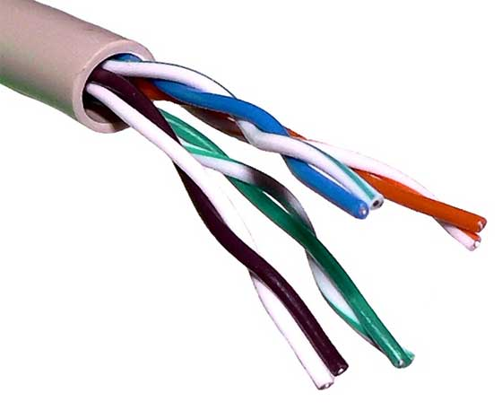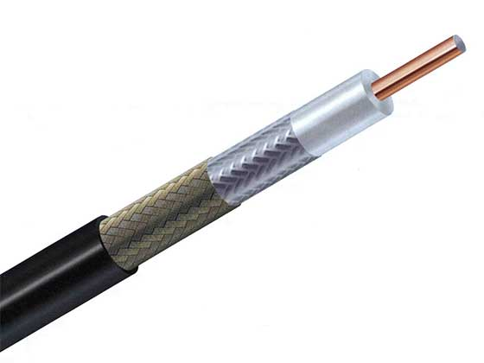

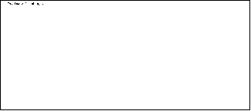

|  |  |  |
| --- | --- | --- |
|  | |  |
|  | supports without inducing unwanted currents in them and though.The most common use for coaxial cables is for television and other signals with bandwidth of multiple megahertz. Although in most homes coaxial cables have been installed for transmission of [TV](http://en.wikipedia.org/wiki/TV) signals, new technologies (such as the [ITU-T](http://en.wikipedia.org/wiki/ITU-T) [G](http://en.wikipedia.org/wiki/G.hn).hn standard) open the possibility of using home coaxial cable for high-speed [home networking](http://en.wikipedia.org/wiki/Home_network) applications [(Ethernet over coax)](http://en.wikipedia.org/wiki/Ethernet_over_coax).  **Figure** **3.2.** **Coaxial** **Cable**  **TWISTED PAIR CABLE**  A cable made by intertwining two separate insulated wires. There are two twisted pair types: shielded and unshielded. A [Shielded Twisted Pair (STP)](http://www.computerhope.com/jargon/s/stpcable.htm) has a fine wire mesh surrounding the wires to protect the transmission; an [Unshielded Twisted Pair (UTP)](http://www.computerhope.com/jargon/u/utpcable.htm) do not. The use of two wires twisted together helps to reduce [crosstalk](http://www.webopedia.com/TERM/C/crosstalk.html) and electromagnetic induction. While twisted-pair cable is used by older telephone [networks](http://www.webopedia.com/TERM/N/network.html) and is the least expensive type of [local-area](http://www.webopedia.com/TERM/L/local_area_network_LAN.html) [network (LAN)](http://www.webopedia.com/TERM/L/local_area_network_LAN.html) cable, most networks contain some twisted-pair cabling at some point along the network.  e.g. [CAT2,](http://www.computerhope.com/jargon/c/cat2.htm) [C](http://www.computerhope.com/jargon/c/cat3.htm)AT3, [C](http://www.computerhope.com/jargon/c/cat4.htm)AT4, [C](http://www.computerhope.com/jargon/c/cat5.htm)AT5, [C](http://www.computerhope.com/jargon/c/cat5.htm)AT5e, [C](http://www.computerhope.com/jargon/c/cat6.htm)AT6, [C](http://www.computerhope.com/jargon/c/cat7.htm)AT7.  Figure 3.3. CAT5 Twisted pair cable  _________________________________________________________________  **Answer!**  **CAT** stands for ***Category,*** which is a classification system for twisted-pair copper wire cables used in Ethernet networking. The different categories define the cable's performance and capacity to transmit data. Here's an overview of each category:  **5** **|** P a g e |
|  | |

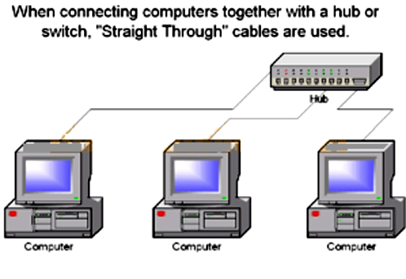

|  |  |  |  |
| --- | --- | --- | --- |
| **Template** | **Hub** | **Switch** | **Router** |
| Layer | Physical layer | Data link layer | Network layer |



|  |  |  |
| --- | --- | --- |
|  | |  |
|  | **Write note on** [**CAT2,**](http://www.computerhope.com/jargon/c/cat2.htm)**CAT3,****CAT4,****CAT5,****CAT5e,****CAT6,****CAT7.**  **Ans:**  **CAT2:** This category supports data transfer rates up to 4 Mbps and is not commonly used in modern networks.  **CAT3:** This category supports data transfer rates up to 10 Mbps and is often used for telephone wiring and low-speed Ethernet networks.  **CAT4:** This category supports data transfer rates up to 16 Mbps and is less common than CAT5 and CAT6 cables.  **CAT5:** This category supports data transfer rates up to 100 Mbps and is commonly used in Ethernet networks.  **CAT5e:** This category supports data transfer rates up to 1 Gbps and is an enhanced version of CAT5 that can handle more data and reduce crosstalk between cables.  **CAT6:** This category supports data transfer rates up to 10 Gbps and is commonly used in high-speed Ethernet networks.  **CAT7:** This category supports data transfer rates up to 10 Gbps and beyond, making it suitable for high-performance networks. It also has shielding to reduce interference from external sources.  ***In*** ***summary,*** ***the*** ***higher*** ***the*** ***category*** ***number,*** ***the*** ***higher*** ***the*** ***data*** ***transfer*** ***rates*** ***and*** ***the*** ***more*** ***advanced*** ***the*** ***cable's*** ***technology.***  _______________________________________________________________________________  **CROSS-OVER** **CABLE**  A cross-over network cable is used to connect two computers directly. It is also used when you connect two hubs/Switches with a normal port on both hubs/Switches. (In other words, the cross cable is used relatively in a rare case.). It is used to connect similar devices.  **Figure** **3.8.** **Cross-Over** **Cable**  **QUESTION: 02**  **What is difference between Hub, Switch and Router?** |
|  | |

|  |  |  |
| --- | --- | --- |
|  | |  |
|  | |  |  |  |  | | --- | --- | --- | --- | | Function | To connect a network of personal computers together, they can be joined through a central hub | Allow connections to multiple devices, manage ports, manage VLAN security settings | Direct data in a network | | Data Transmission form | electrical signal or bits | frame & packet | packet | | Port | 4/12 ports | multi-port, usually between 4 and 48 | 2/4/5/8 ports | | Transmission type | Frame flooding, unicast, multicast or broadcast | First broadcast, then unicast and/or multicast depends on the need | At Initial Level  Broadcast then Unicast and multicast | | Device type | Non-intelligent device | Intelligent device | Intelligent device | | Used in(LAN, MAN, WAN) | LAN | LAN | LAN, MAN, WAN | | Transmission mode | Half duplex | Half/Full duplex | Full duplex | | Speed | 10Mbps | 10/100Mbps, 1Gbps | 1-100Mbps(wireless); 100Mbps1Gbps(wired) | | Address used for data transmission | MAC address | MAC address | IP address |   _________________________________________________________________________________  **QUESTION: 03**  **What should I buy for my network, Hub, Switch or Router?** **Answer:**  A ***router*** is used to connect two different networks whereas we have only one network, thus there is no need to buy router. Let’s talk about switch and hub. In most of the cases, *switch* *perform* *same* *as* *hub*. People use these two words interchangeably. Generally, switch and hub are used in the same networks. A ***hub*** extends the network by providing more ports. I can choose to buy switch or hub according to my demands. If there is more traffic in the network (more devices connected to the network) then it’s a better option to buy switch instead of hub. If there is not that much traffic (for 2 or 3 devices) then it’s a better option to buy hub instead of a switch.  _____________________________________________________________________________________ |
|  | |

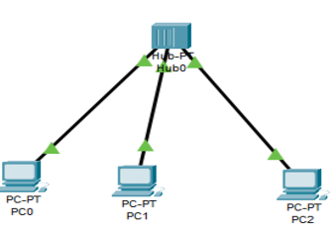

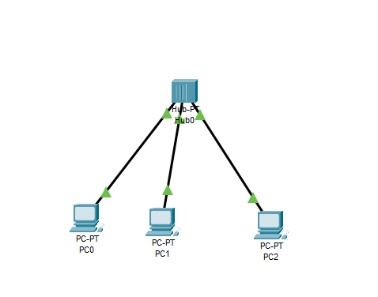

|  |  |  |
| --- | --- | --- |
|  | |  |
|  | **QUESTION: 04**  **List networking hardware vendors?**  **Answer:**  Following is the list of hardware vendors:  • Cisco  • HPE/Aruba • Juniper  • Huawei • Arista  • VMware • Riverbed • Netscout  • Extreme Networks • Dell/EMC  **______________________________________________________________________________**  **QUESTION:05**  **Connect the devices as follows and ping to show the connectivity**  **Connection:** |
|  | |

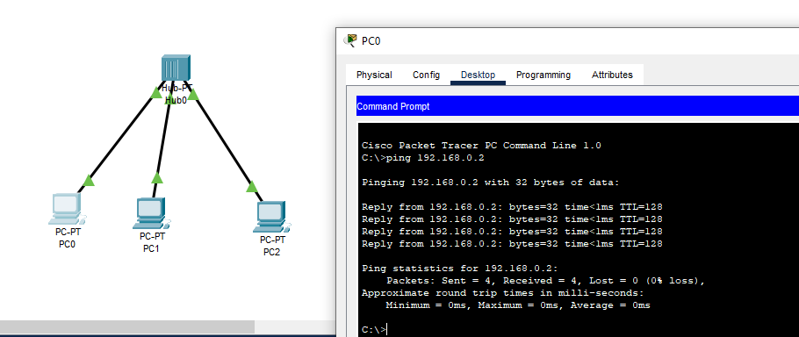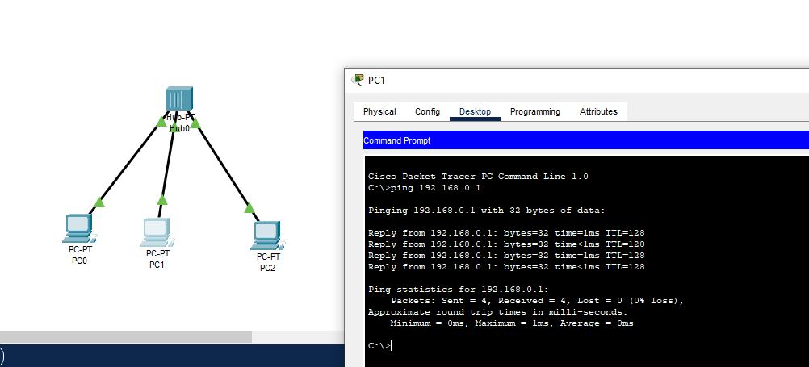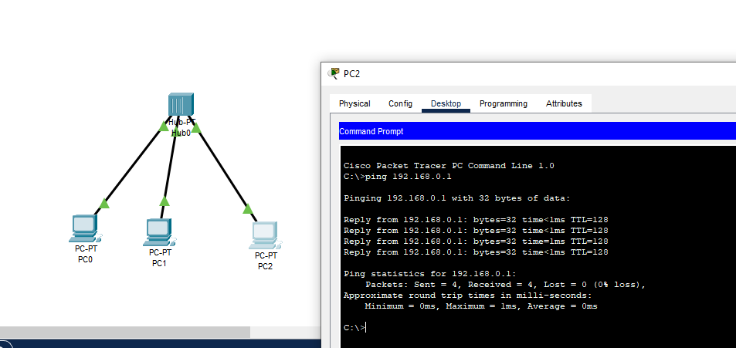

|  |  |  |
| --- | --- | --- |
|  | |  |
|  | **QUESTION: 06**  **In the above network, transfer the data from one computer to another. Have you!** |
|  | |

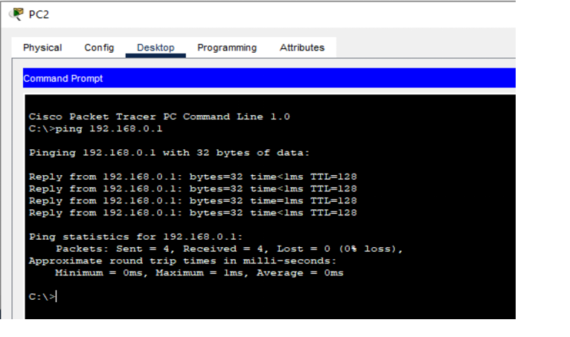

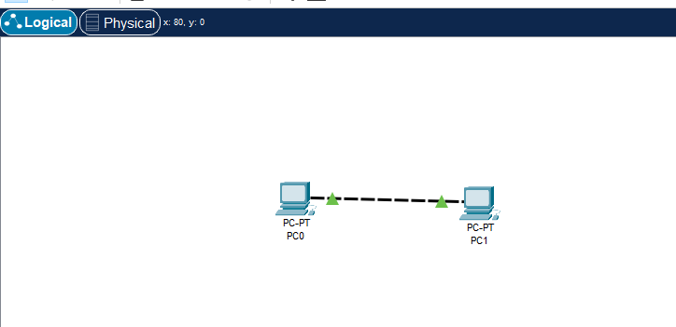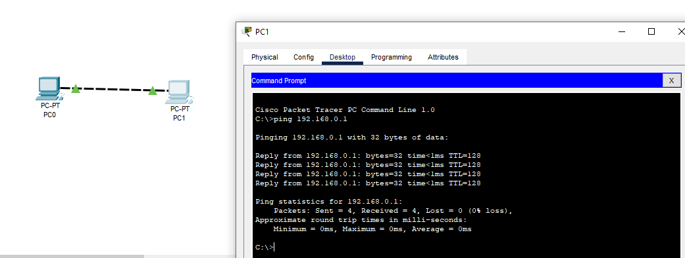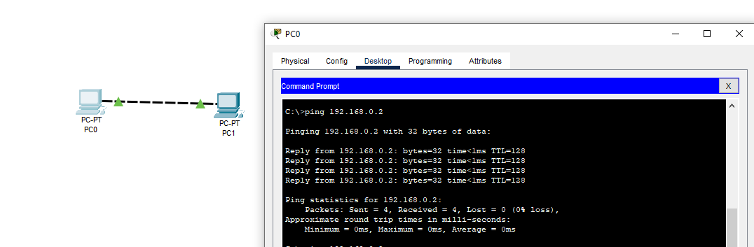

|  |  |  |
| --- | --- | --- |
|  | |  |
|  | **QUESTION: 07**  **Connect two computer directly as follows and ping to show the connectivity**  _________________________________________________________________  **QUESTION: 08**  **In the above network, transfer the data from one computer to another. Have you!** |
|  | |